Computer Vision Based Ambulance Detection and
Emergency SMS Alert System

MP2911 – MINI PROJECT

Submitted by

MERSHICK J
(URK23CS5056)

in partial fulfillment for the award of the degree of

BACHELOR OF TECHNOLOGY
in
COMPUTER SCIENCE AND ENGINEERING
(AI/AIML)

Academic Year 2025-2026
EVEN SEMESTER

DIVISION OF ARTIFICIAL INTELLIGENCE AND MACHINE LEARNING
SCHOOL OF COMPUTER SCIENCE AND TECHNOLOGY


April 2026

BONAFIDE CERTIFICATE

This is to certify that the mini project report entitled “ Computer Vision Based Ambulance Detection and Emergency SMS Alert System” is a bonafide work done during the even semester of the academic year 2025-2026 by
MERSHICK J (URK23CS5056)
in partial fulfillment of the requirements for the award of the degree of Bachelor of Technology in Computer Science and Engineering (AI /AIML) of Karunya Institute of Technology and Sciences.

Signature of the Supervisor

Mrs. Angelin Jeba P
Assistant Professor
Division of Artificial Intelligence and Machine Learning

Submitted for the Viva Voce held on ______18/04/2026_____________

DECLARATION

We, the undersigned, hereby declare that the mini project titled “Computer Vision Based Ambulance Detection and Emergency SMS Alert System” is an original work carried out by us. We are fully responsible for the planning, analysis, design, development, and implementation of the Mini Project described in this report.
To the best of our knowledge and belief:
- The mini project requirements have been carefully studied, analyzed, and accurately documented in this report.
- The mini project has been developed in accordance with the defined specifications, functionalities, and objectives.
- Appropriate methodologies, coding standards, and security practices have been followed to ensure the quality and reliability of the mini Project.
- Sufficient importance has been given to testing, debugging, and validation to deliver a stable and error-free solution.
- Any issues, ambiguities, or changes encountered during the mini Project development have been identified and addressed appropriately.
- The mini project was successfully completed within the stipulated time frame, achieving the intended outcomes while maintaining the required quality standards.

Signature of student Signature of the Supervisor

TABLE OF CONTENTS

S.No | Chapter Title | Page No.
 | Abstract | 1
 | Introduction | 2
 | Literature Survey | 3
 | Proposed Methodology | 4
 | Results and Discussions | 5
 | Conclusion | 6
 | References | 7
 | Appendix A- Sample Code  Appendix B – Output Screenshots  Appendix C- Outcome Achieved | 8  11  12

ABSTRACT
With the rapid increase in urban traffic, ensuring timely movement of emergency vehicles such as ambulances has become a major challenge. Traffic congestion often delays ambulances, which can lead to critical consequences for patients requiring immediate medical attention. Traditional traffic monitoring systems rely on manual observation through CCTV cameras, which are inefficient and lack real-time automated decision-making capabilities. To address this issue, this project proposes a real-time ambulance detection and alert system using computer vision and deep learning techniques.
The proposed system utilizes a YOLO (You Only Look Once) based deep learning model trained on a custom dataset of ambulance images. The dataset is prepared and annotated using modern tools, ensuring that the model can accurately identify ambulances under various conditions such as different angles, lighting environments, and traffic scenarios. The trained model is capable of detecting ambulances in real-time video streams with high accuracy and speed, making it suitable for practical deployment.
The system uses OpenCV for capturing and processing video input from either a live camera feed or pre-recorded videos. Each frame of the video is analyzed by the YOLO model to detect objects, and the system specifically filters detections corresponding to ambulances. Once an ambulance is identified with a confidence level above a predefined threshold, the system triggers an automated alert mechanism.
To enable instant communication, the system integrates an SMS alert feature using the Twilio API. When an ambulance is detected, a notification message is sent to a predefined mobile number, informing the concerned authority or user. This feature helps in taking immediate action, such as clearing traffic or prioritizing ambulance movement, thereby reducing response time.
The proposed system reduces the dependency on manual monitoring and improves the efficiency of emergency traffic management. It demonstrates the practical application of artificial intelligence, computer vision, and cloud communication technologies in solving real-world problems. The system is scalable and can be extended for use in smart city applications, including automated traffic signal control and multi-camera monitoring systems.
In conclusion, this project provides an effective solution for real-time ambulance detection and alert generation. By combining deep learning with automated communication, the system enhances emergency response capabilities and contributes to improving public safety and healthcare outcomes.

1

INTRODUCTION
In recent years, rapid urbanization and the increasing number of vehicles on roads have led to severe traffic congestion, especially in metropolitan cities. One of the most critical consequences of traffic congestion is the delay faced by emergency vehicles such as ambulances. Ambulances play a vital role in saving human lives, and even a small delay in reaching hospitals can result in serious health risks or loss of life. Therefore, there is a strong need for an intelligent system that can automatically detect ambulances in traffic and assist in improving emergency response time.
Traditional traffic monitoring systems rely heavily on manual observation using CCTV cameras and human operators. These methods are not only time-consuming but also prone to errors due to fatigue and lack of real-time responsiveness. Moreover, such systems do not provide any automated mechanism to identify emergency vehicles and take immediate action. With advancements in technology, especially in the field of Artificial Intelligence and Computer Vision, it is now possible to develop automated systems that can analyze video data and detect objects in real time.
This project focuses on the development of a real-time ambulance detection system using deep learning techniques. The system is based on the YOLO (You Only Look Once) algorithm, which is one of the most efficient and widely used object detection models. YOLO is capable of detecting multiple objects in an image or video frame with high accuracy and speed, making it suitable for real-time applications. In this project, a custom dataset of ambulance images is used to train the model so that it can accurately identify ambulances in different traffic scenarios.
The system uses OpenCV to capture and process video input either from a live camera or a pre-recorded video. Each frame of the video is passed through the trained YOLO model, which detects objects and identifies ambulances by drawing bounding boxes around them. Once an ambulance is detected with a certain confidence level, the system triggers an alert mechanism.
To enhance the functionality of the system, an automated SMS alert feature is integrated using the Twilio API. This allows the system to send instant notifications to a predefined mobile number whenever an ambulance is detected. Such alerts can be useful for traffic authorities or emergency response teams to take quick action, such as clearing traffic or providing priority passage to the ambulance.
The integration of computer vision, deep learning, and cloud communication services makes this system highly efficient and scalable. It reduces the dependency on manual monitoring and ensures faster decision-making in emergency situations. The proposed system can also be extended in the future to automatically control traffic signals and create green corridors for ambulances.
In conclusion, this project demonstrates how modern technologies like deep learning and computer vision can be applied to solve real-world problems related to traffic management and emergency services. The system provides an effective solution for detecting ambulances and sending real-time alerts, thereby contributing to improved public safety and smarter city infrastructure. 2

LITERATURE SURVEY
The field of object detection has seen significant advancements with the development of deep learning techniques, particularly Convolutional Neural Networks (CNNs). Traditional methods of object detection relied on manual feature extraction techniques such as edge detection, color segmentation, and shape analysis. However, these approaches were limited in accuracy and performance, especially in complex real-world environments like traffic scenes. With the introduction of deep learning, automated feature extraction and high-accuracy detection have become possible.

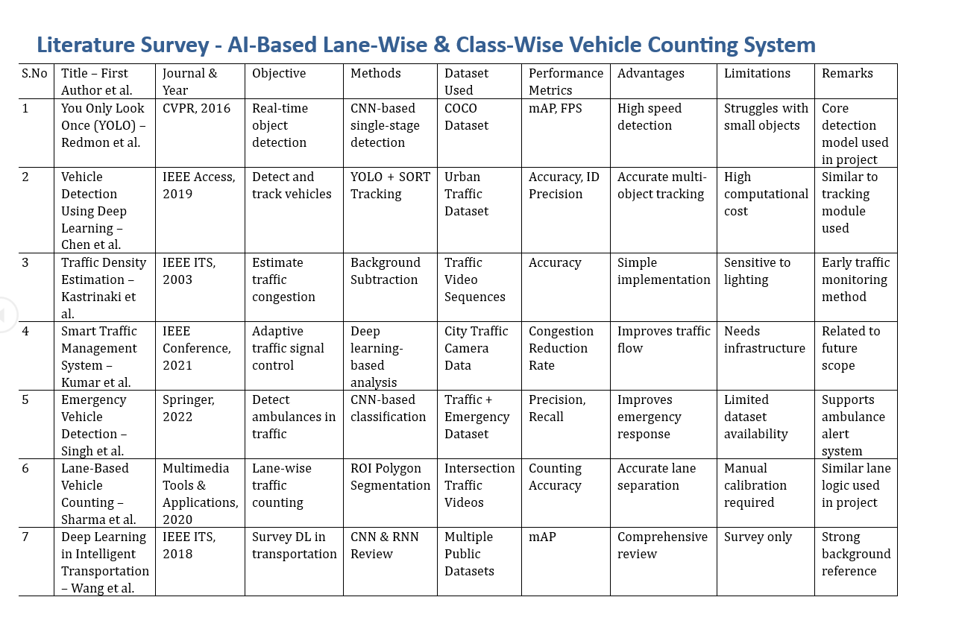

3

PROPOSED METHODOLOGY
The proposed system is designed to detect ambulances in real-time traffic video using computer vision and deep learning techniques, and to generate an automatic SMS alert when an ambulance is identified. The methodology follows a structured pipeline that includes video acquisition, preprocessing, object detection, validation, and alert generation.
The first step in the system is video input acquisition. The system captures video either from a live camera feed such as a CCTV camera or from a pre-recorded video file. The video is processed frame-by-frame using the OpenCV library. Each frame acts as an individual image that is analyzed by the detection model. This approach enables real-time processing and ensures that the system continuously monitors the traffic scene.
The next step is frame preprocessing, where each captured frame is resized and formatted to match the input requirements of the deep learning model. Resizing the frame helps in reducing computational complexity and improves processing speed without significantly affecting detection accuracy. Additional preprocessing techniques such as normalization may also be applied to enhance the performance of the model.
The core component of the system is the ambulance detection module, which uses a YOLO (You Only Look Once) deep learning model. The model is trained on a custom dataset containing images of ambulances under different conditions. YOLO processes the entire frame in a single pass and predicts bounding boxes along with class labels and confidence scores. This allows the system to detect ambulances quickly and accurately in real time.
Video Input
YOLO Detection

Ambulance Identified

Twilio SMS Alert

4

RESULTS AND DISCUSSION
The proposed system was successfully implemented and evaluated using multiple traffic video samples containing ambulances under different conditions. The YOLO-based deep learning model demonstrated the ability to detect ambulances accurately in real-time video streams. The system processed each frame efficiently and displayed bounding boxes around detected ambulances along with appropriate labels, confirming correct identification.
During testing, the system was able to identify ambulances with a high confidence level when the vehicle was clearly visible in the frame. The detection performance was consistent across different scenarios, including moderate traffic conditions and varying backgrounds. The integration of OpenCV ensured smooth frame processing and real-time visualization, allowing the system to operate without noticeable delay.
A key feature of the system is the automated SMS alert functionality. Upon detecting an ambulance, the system successfully triggered an alert using the Twilio API. The SMS was delivered to the registered mobile number within a short time, demonstrating the effectiveness of the communication module. This confirms that the system not only detects ambulances but also provides immediate notification, which is essential for real-world emergency response.
The system performs best under favorable conditions such as good lighting, clear visibility, and minimal occlusion. In such cases, the detection accuracy is high, and false positives are minimal. However, certain limitations were observed during testing. In low-light conditions or during nighttime scenarios, the detection accuracy may decrease slightly due to reduced visibility. Similarly, when the ambulance is partially blocked by other vehicles or objects, the model may face difficulty in identifying it correctly. These challenges are common in computer vision systems and can be improved with a larger and more diverse training dataset.
Another observation is related to processing speed. By resizing frames and optimizing the model, the system achieves near real-time performance on standard hardware. This makes it suitable for deployment in practical environments such as traffic monitoring systems. The SMS alert mechanism was designed to trigger only once per detection event, preventing repeated alerts and ensuring efficient use of resources.
Overall, the results indicate that the proposed system is effective in detecting ambulances and generating real-time alerts. The combination of deep learning and cloud-based communication provides a reliable solution for emergency traffic management. The system meets the project objectives and demonstrates the practical application of artificial intelligence in improving public safety and emergency response systems.

5

CONCLUSION
The proposed project successfully demonstrates the design and implementation of a real-time ambulance detection system using computer vision and deep learning techniques. The system utilizes a YOLO-based model trained on a custom dataset to accurately identify ambulances from video input. By integrating OpenCV for video processing and the Twilio API for SMS communication, the project provides a complete end-to-end solution for detecting emergency vehicles and generating alerts.
One of the key achievements of this project is the ability to perform real-time detection with high efficiency. The YOLO model enables fast and accurate object detection, making it suitable for applications that require immediate response. The system effectively identifies ambulances in various traffic scenarios and highlights them using bounding boxes, ensuring clear visualization of the detection results.
The integration of the SMS alert mechanism adds significant value to the system. Once an ambulance is detected, an automatic notification is sent to a predefined mobile number. This feature ensures that relevant authorities or users are informed instantly, allowing them to take quick action. Such a system can help reduce delays in emergency situations and improve overall response time, which is critical in saving lives.
The project also highlights the importance of combining multiple technologies to solve real-world problems. The use of deep learning for object detection, computer vision for video analysis, and cloud-based APIs for communication demonstrates how different domains can be integrated to create an efficient and intelligent system. The system reduces the need for manual monitoring and provides a scalable solution for traffic management.
Although the system performs well under normal conditions, certain limitations were observed, such as reduced accuracy in low-light environments and challenges in detecting partially occluded ambulances. These limitations can be addressed in future work by improving the dataset, enhancing the model, and incorporating additional sensors or techniques.
In conclusion, the developed system meets the objectives of detecting ambulances in real time and sending automated alerts. It provides a practical and effective solution for emergency traffic management and can be further extended for use in smart city applications. The project demonstrates the potential of artificial intelligence in improving public safety and highlights its importance in modern technological solutions.

6

REFERENCES

- Redmon, J., Divvala, S., Girshick, R., & Farhadi, A. (2016). You Only Look Once: Unified, Real-Time Object Detection. Proceedings of the IEEE Conference on Computer Vision and Pattern Recognition (CVPR), pp. 779–788.
- Bochkovskiy, A., Wang, C. Y., & Liao, H. Y. M. (2020). YOLOv4: Optimal Speed and Accuracy of Object Detection. arXiv preprint arXiv:2004.10934.
- Ultralytics. (2023). YOLOv8 Documentation. Available at: https://docs.ultralytics.com/
- Bradski, G. (2000). The OpenCV Library. Dr. Dobb’s Journal of Software Tools.
- OpenCV. (2023). Open Source Computer Vision Library Documentation. Available at: https://opencv.org/
- Twilio. (2023). Twilio SMS API Documentation. Available at: https://www.twilio.com/docs/sms
- Roboflow. (2023). Roboflow: Manage and Improve Your Computer Vision Datasets. Available at: https://roboflow.com/
- Paszke, A., Gross, S., Massa, F., et al. (2019). PyTorch: An Imperative Style, High-Performance Deep Learning Library. Advances in Neural Information Processing Systems (NeurIPS).
- Goodfellow, I., Bengio, Y., & Courville, A. (2016). Deep Learning. MIT Press.
- Szeliski, R. (2010). Computer Vision: Algorithms and Applications. Springer.

7

APPENDIX A – SAMPLE CODE

import cv2
from ultralytics import YOLO
import torch
from twilio.rest import Client

# Twilio Configuration
account_sid = "YOUR_ACCOUNT_SID"
auth_token = "YOUR_AUTH_TOKEN"
twilio_number = "YOUR_TWILIO_NUMBER"
receiver_number = "+91XXXXXXXXXX"

client = Client(account_sid, auth_token)

def send_sms():
message = client.messages.create(
body="🚑 Ambulance Detected! Please take necessary action.",
from_=twilio_number,
to=receiver_number
)
print("SMS Sent")

# Load YOLO model
device = "cuda" if torch.cuda.is_available() else "cpu"
model = YOLO("ambulance2.pt")
model.to(device) 8

# Video input
cap = cv2.VideoCapture("video2.mp4")

alert_sent = False
CONF_THRESHOLD = 0.5

while True:
ret, frame = cap.read()
if not ret:
break

# Resize frame
input_frame = cv2.resize(frame, (640, 480))

# Run detection
results = model(input_frame, conf=CONF_THRESHOLD)[0]

ambulance_detected = False

for box, cls, conf in zip(results.boxes.xyxy, results.boxes.cls, results.boxes.conf):
label = model.names[int(cls)].lower()

if label != "ambulance":
continue

ambulance_detected = True
9
# Scale box to original frame
scale_x = frame.shape[1] / 640
scale_y = frame.shape[0] / 480
x1, y1, x2, y2 = map(int, box)

x1 = int(x1 * scale_x)
y1 = int(y1 * scale_y)
x2 = int(x2 * scale_x)
y2 = int(y2 * scale_y)

# Draw bounding box
cv2.rectangle(frame, (x1, y1), (x2, y2), (0, 255, 0), 2)
cv2.putText(frame, "AMBULANCE", (x1, y1 - 10),
cv2.FONT_HERSHEY_SIMPLEX, 0.7, (255, 255, 0), 2)

# Send SMS only once
if ambulance_detected and not alert_sent:
send_sms()
alert_sent = True

cv2.imshow("Ambulance Detection", frame)

if cv2.waitKey(1) & 0xFF == ord('q'):
break

cap.release()
cv2.destroyAllWindows()
10

APPENDIX B – OUTPUT SCREENSHOTS

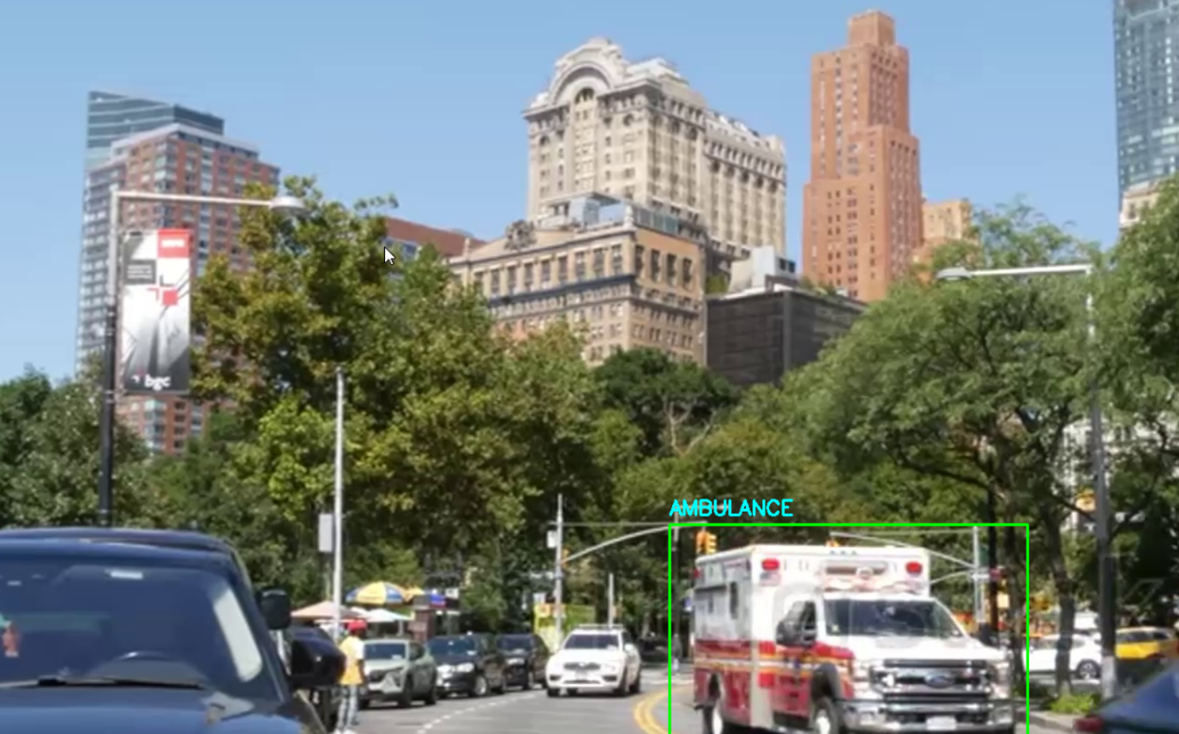

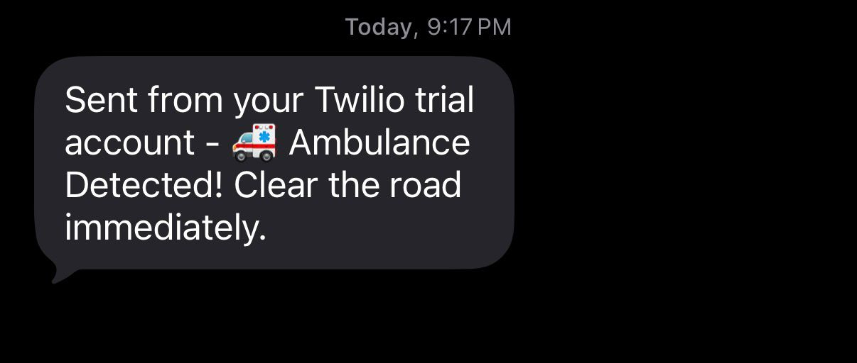

11

APPENDIX C – OUTCOME ACHIEVED
This project successfully achieved its objective of developing a real-time ambulance detection and alert system using computer vision and deep learning techniques. The system was able to process video input efficiently and detect ambulances using a trained YOLO model. The detection results were displayed with bounding boxes and labels, clearly indicating the presence of an ambulance in the video frames.
One of the major outcomes of the project is the successful implementation of a custom-trained deep learning model. The model was trained using a dataset of ambulance images, which improved its ability to accurately identify ambulances under different traffic conditions. The system demonstrated reliable performance in real-time scenarios, especially in well-lit environments with clear visibility.
Another significant achievement is the integration of the SMS alert mechanism using the Twilio API. The system was able to send instant notifications to a registered mobile number whenever an ambulance was detected. This confirms that the system not only performs detection but also provides immediate communication, which is crucial for emergency response.
The system also demonstrated efficient processing speed by analyzing video frames in near real time. The use of OpenCV and optimized model input ensured smooth performance without significant lag. Additionally, the implementation of a control mechanism to send alerts only once per detection event helped in avoiding repeated notifications.
Overall, the project achieved the following outcomes:
- Successful real-time detection of ambulances using a YOLO deep learning model.
- Accurate identification and visualization of ambulances in traffic video.
- Automatic SMS alert generation using Twilio API.
- Efficient video processing and real-time performance.
- Practical application of computer vision in emergency traffic management.
The project demonstrates how modern technologies such as deep learning, computer vision, and cloud communication can be integrated to solve real-world problems. The system can be further enhanced and deployed in smart city environments to improve emergency response systems and public safety.

12

